**启动YARN TimelineV2 TimelineReader**

启动TimelineReader

*yarn timelinereader*

启动信息如下：

*$ /usr/jdk64/jdk1.8.0_77/bin/jps*

*2293 TimelineReaderServer*

*$ netstat -anp|grep 2293*

*tcp 0 0 0.0.0.0:18188 0.0.0.0:* LISTEN 2293/java*

配置webapps/ui2/config中的

*timelineWebAddress: "fys2.cmss.com:18188"*

REST API如下：

*<http://fys2.cmss.com:18188/ws/v2/timeline/flows>*

*[ {*

*"metrics": [],*

*"events": [],*

*"idprefix": 0,*

*"flowruns": [{*

*"metrics": [],*

*"events": [],*

*"idprefix": 0,*

*"id": "hdfs@my-sleeper/1535536923815",*

*"info": {*

*"SYSTEM_INFO_FLOW_NAME": "my-sleeper",*

*"SYSTEM_INFO_USER": "hdfs",*

*"SYSTEM_INFO_FLOW_RUN_ID": 1535536923815,*

*"SYSTEM_INFO_FLOW_VERSION": "1"*

*},*

*"isrelatedto": {},*

*"relatesto": {},*

*"type": "YARN_FLOW_RUN"*

*}],*

*"id": "yarn_cluster/1535500800000/hdfs@my-sleeper",*

*"info": {*

*"UID": "yarn_cluster!hdfs!my-sleeper",*

*"SYSTEM_INFO_CLUSTER": "yarn_cluster",*

*"SYSTEM_INFO_FLOW_NAME": "my-sleeper",*

*"SYSTEM_INFO_USER": "hdfs",*

*"SYSTEM_INFO_DATE": 1535500800000,*

*"FROM_ID": "yarn_cluster!1535500800000!hdfs!my-sleeper"*

*},*

*"isrelatedto": {},*

*"relatesto": {},*

*"type": "YARN_FLOW_ACTIVITY"*

*}]*

直接打开YARN UI2后，可能抛出

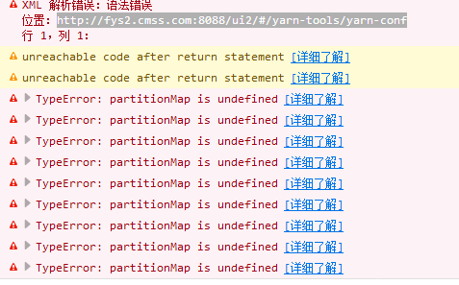

*遇到上面的问题，再打开一个链接即可*

*<http://fys2.cmss.com:8088/ui2/#/yarn-tools/yarn-conf>*

*YARN-Flow-Activity*

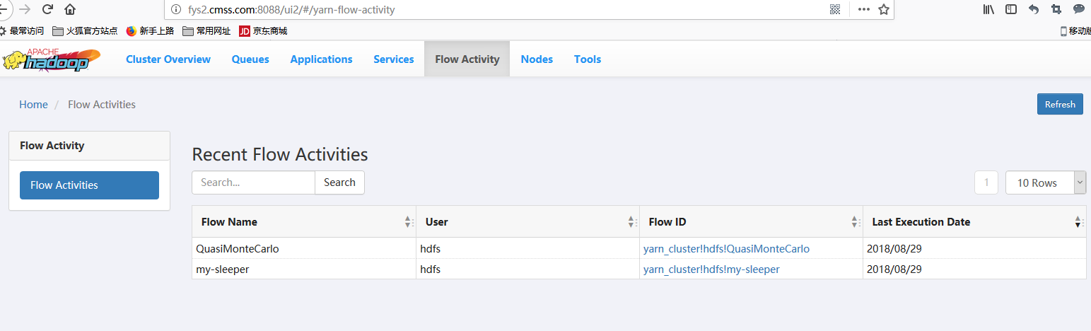

*具体的Flow信息如下：*

